Hill Stations:

shogran

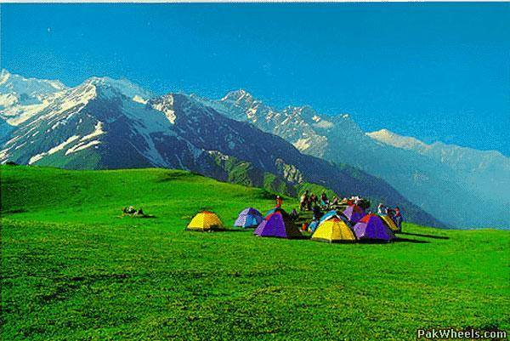

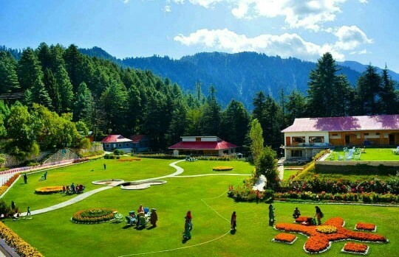

**Shogran** is a hill station situated on a green plateau in the Kaghan Valley, northern Pakistan at a height of 2,362 metres (7,749ft) above sea level. Shogran is located at a distance of 34 kilometres (21mi) away from Balakot. The road from Islamabad to Kiwai is metalled and measures 212 kilometres (132mi). Hotels and motels are available at affordable costs. Mobile phone services is also available there by Telenor and Mobilink. The local people are friendly and peaceful. It is accessible in the summer. It attracts families and explorers alike. You should not miss a trip to Forest Rest House. Most of the people sit and relax in its huge lush green lawns. Entry might be restricted when senior officials visit or stay at rest houses. Views of Sri Paya and 'Musa ka Musala Peak' are really nice from the lawns of the rest house.